Q1) Find max element in an array

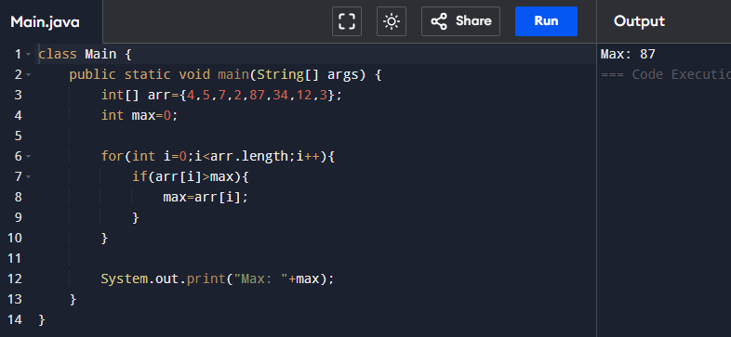

Q2) Count the number of even and odd numbers in a list

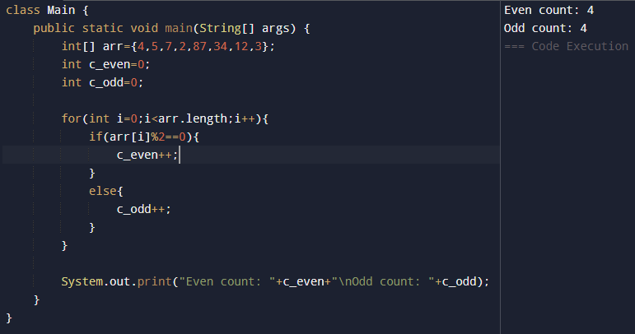

Q3) Reverse a string

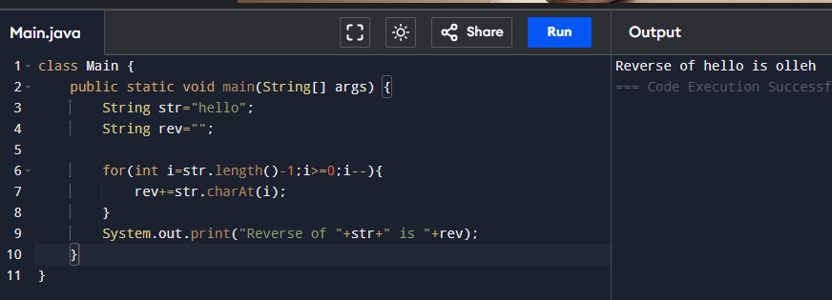

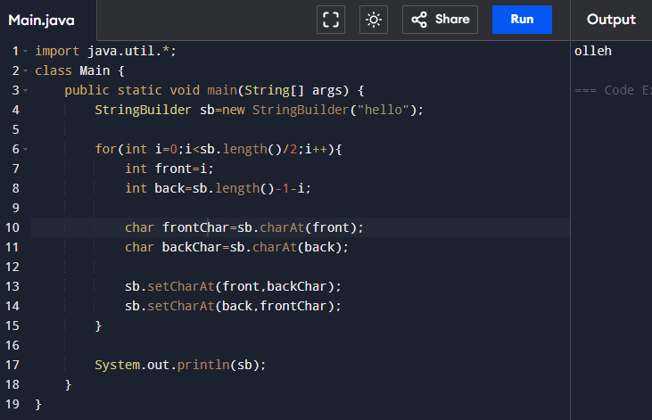

Q4) Program for prime number

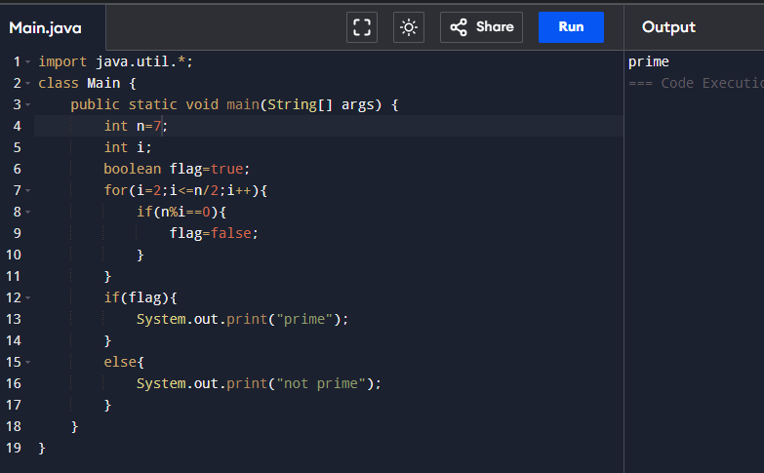

Q5) Program for Fibonacci series upto N terms

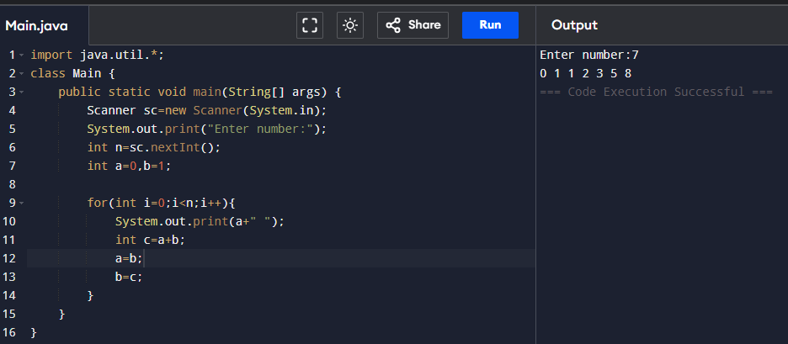

Q6) Find the 2nd largest element in the array

Q7) Check if a string is palindrome

Q8) Sort array using BubbleSort

Q9) Find sum of the digits of a number

Q10) Program for factorial (simple, recursion)

Q11) Merge two sorted arrays into one

Q12) Program to count the frequency if elements in an array

Q13) Find missing number in a range from 1 to N

Q14) Anagrams

Q15) Remove duplicate elements from an array

Q16) Find largest sum subarray

Q17) Armstrong and strong

Q18) Rotate array to left by k steps

Q19) Find the intersection of two arrays

Q20) Move all zeroes to the end of an array

Q21) Implement binary search

Q22) Check if a number is a perfect square

Q23) Count vowels and consonants in a string

Q24) Find GCD of two numbers

Q25) Convert a binary number to decimal

Q26) Find first non-repeating characters in a string

Q27) Implement a stack using arrays

Q28) Implement queue using two stacks

Q29) Check if brackets are balanced using array

Q30) Find majority element in an array(if any)